Observation 1:

After clicking on edit button, in the edit profile page the previously uploaded photo, skills and the company name is not visible and its allowing to submit after filling skills field but keeping company and photo unfilled.

About me page (after logging with a new user):

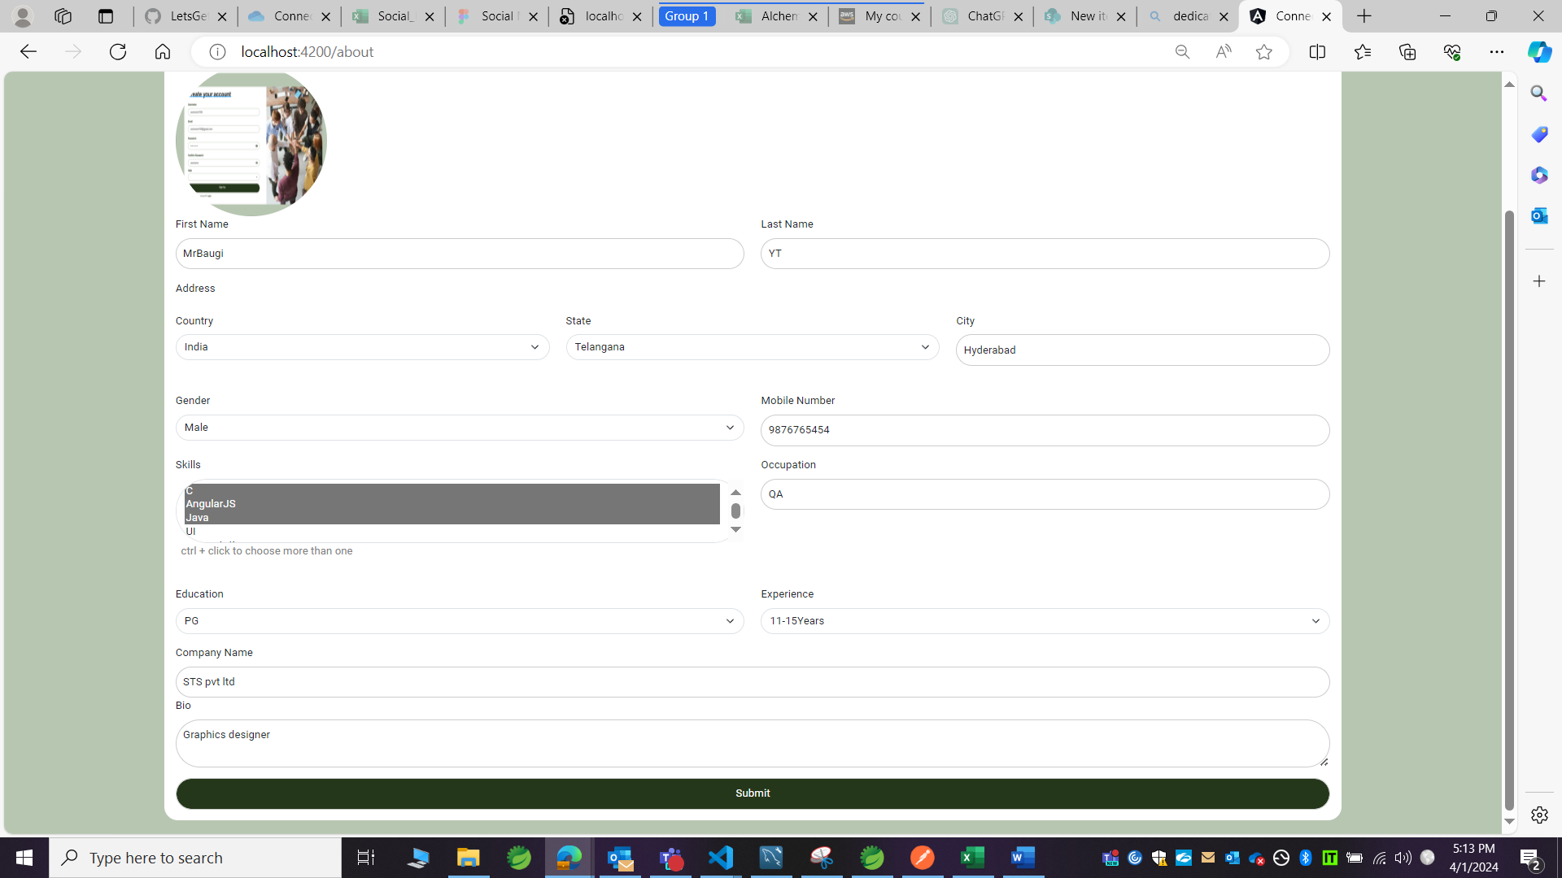

Profile page:

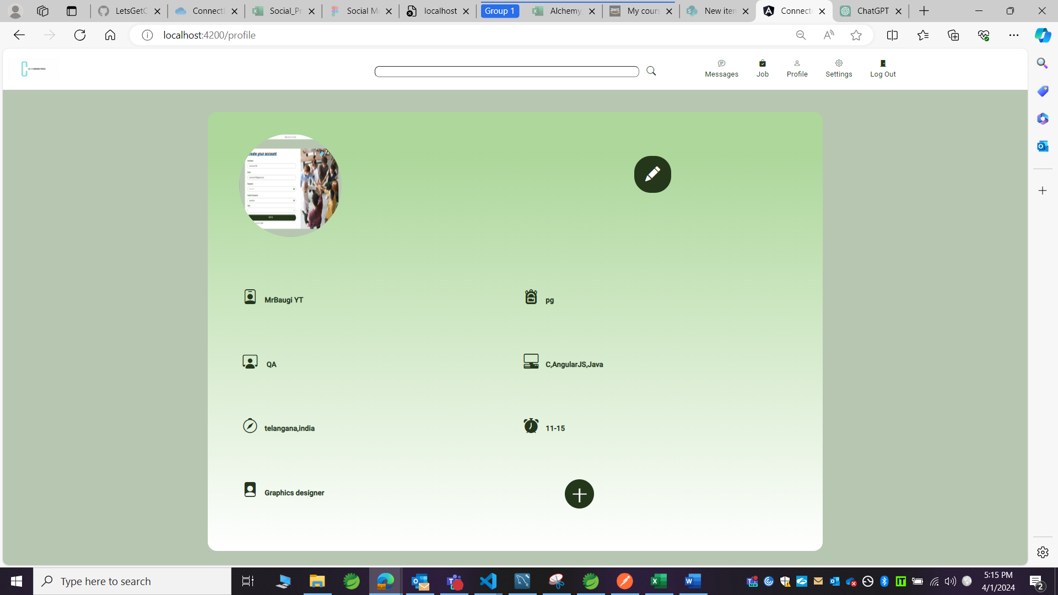

Edit profile page:

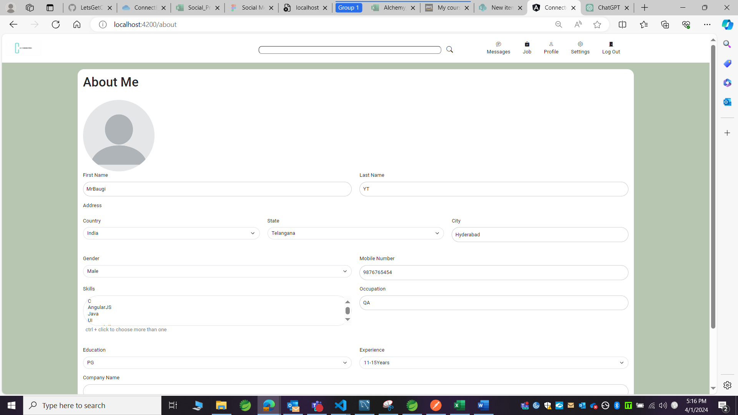

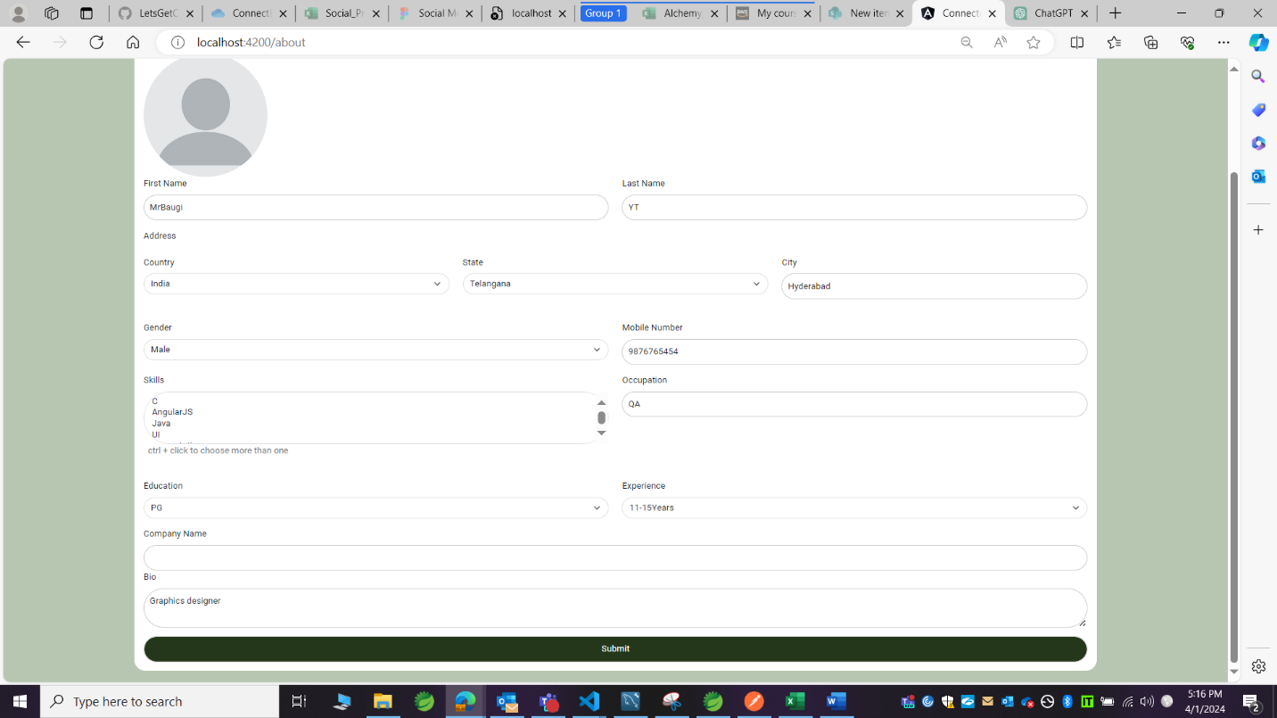

After submit (Allowing to submit without the profile photo and company name):

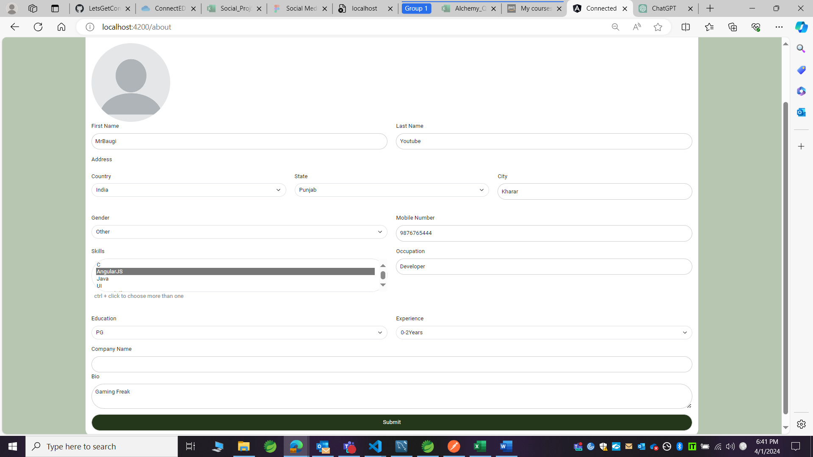

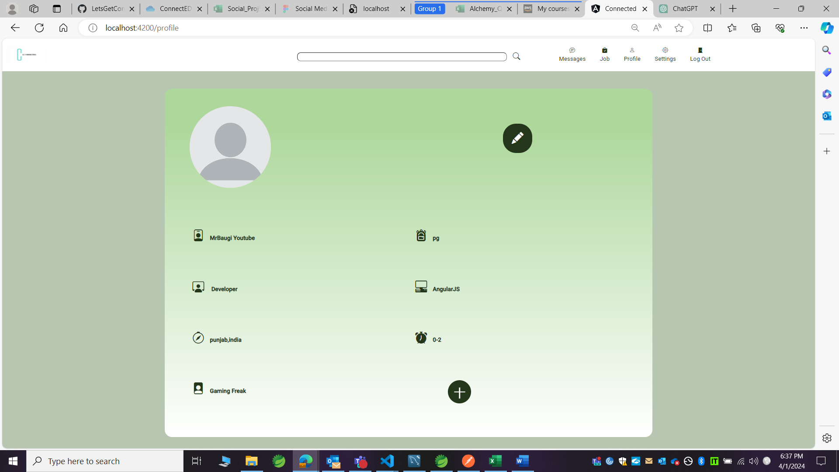

Observation 2:

The icon related to that page is not highlighted, should be highlighted to ensure that we are in that particular page.

Profile page:

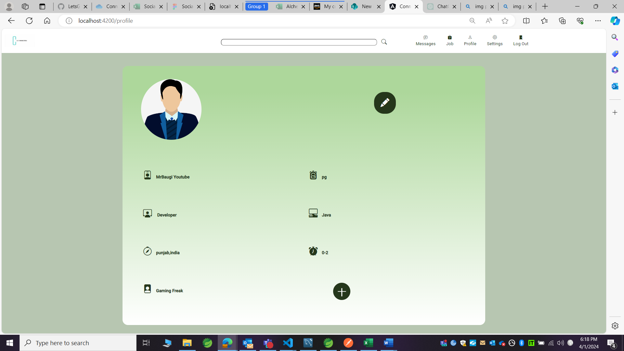

Profile icon not highlighted.

